TASK 1. Dennis Tikhomirov (Dzianis Tsikhamirau)

PART 1.

Create user

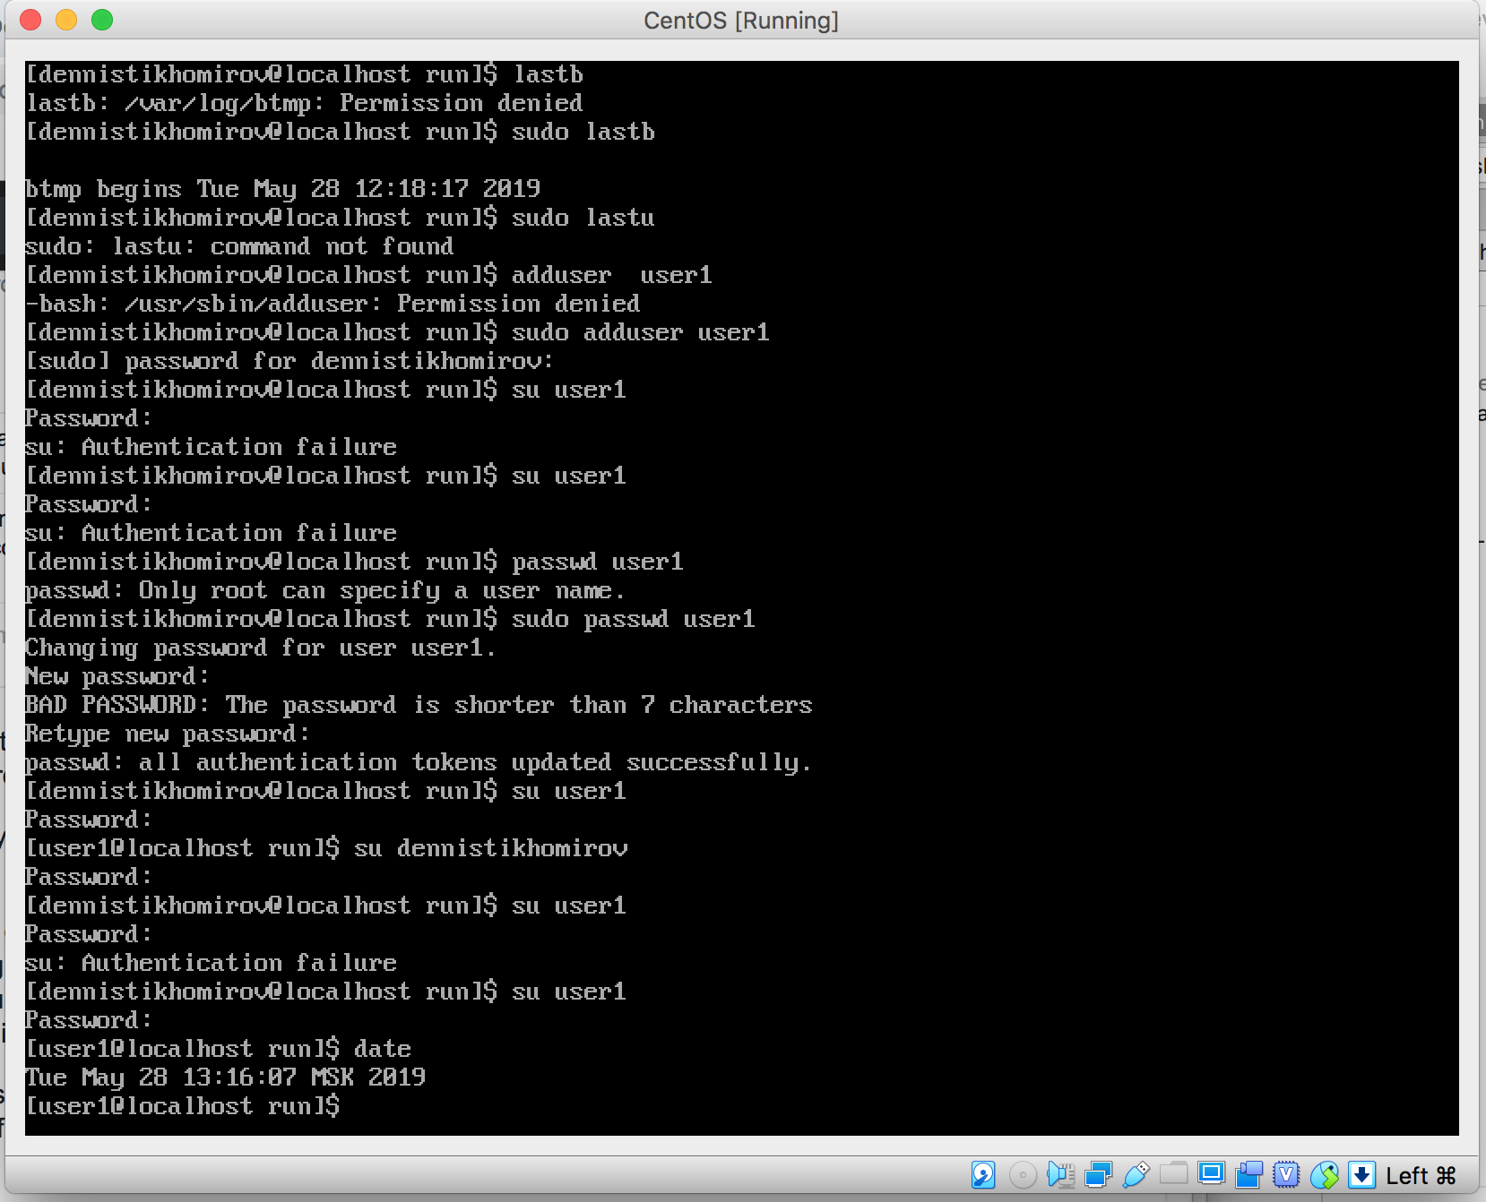

Age of system (I believe time of system installation equals time of creation directory root)

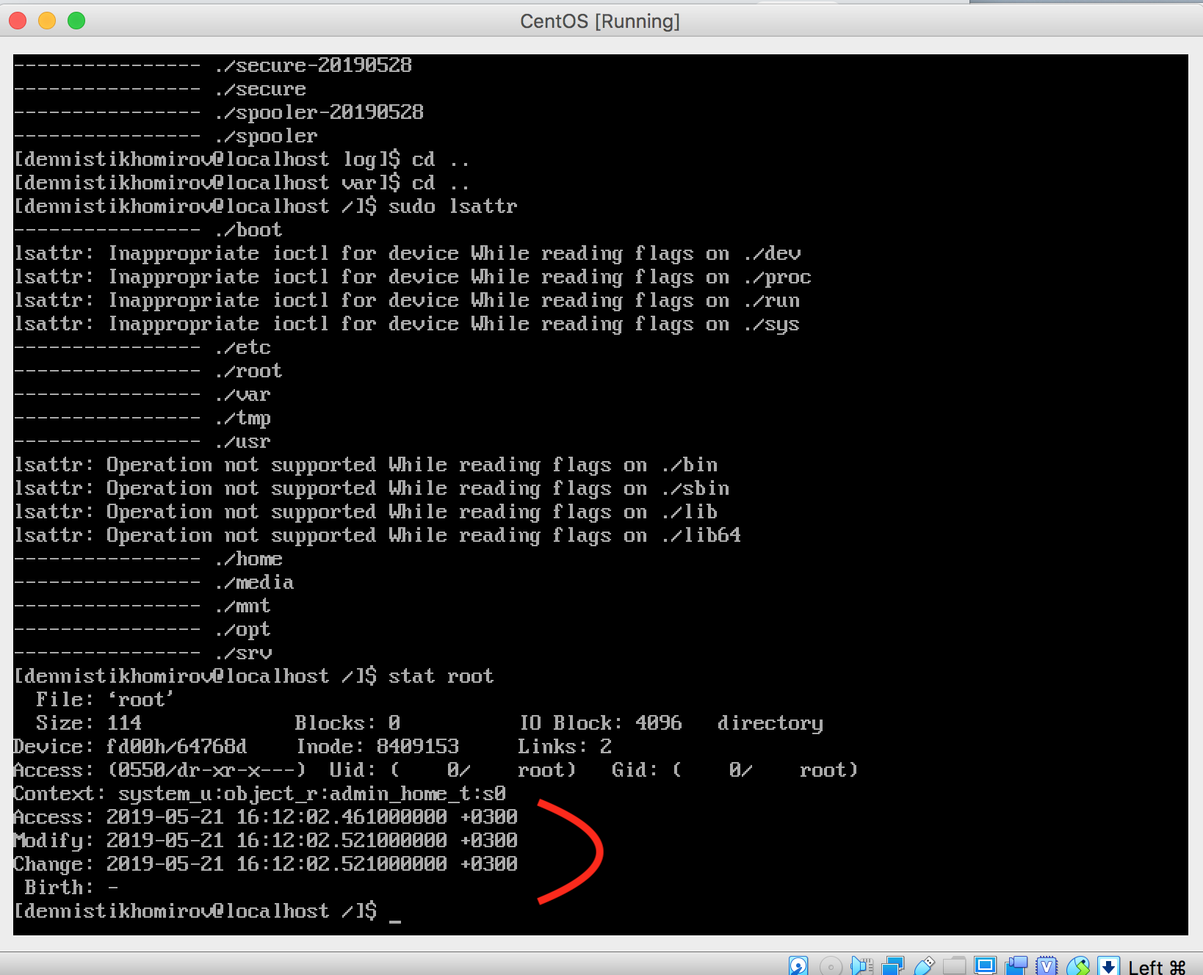

Last five logins

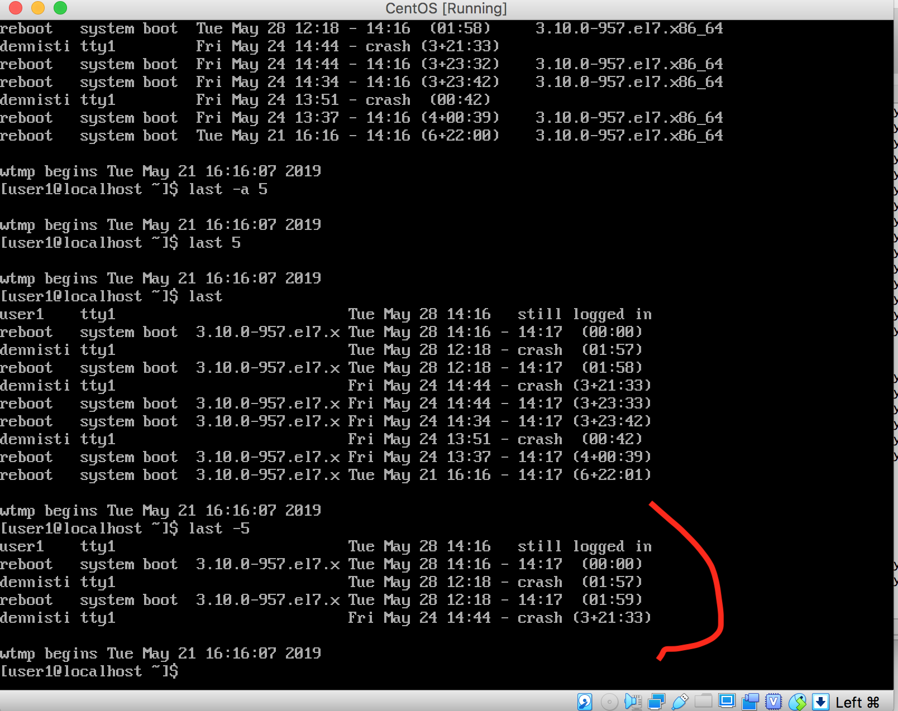

Failed login attempts

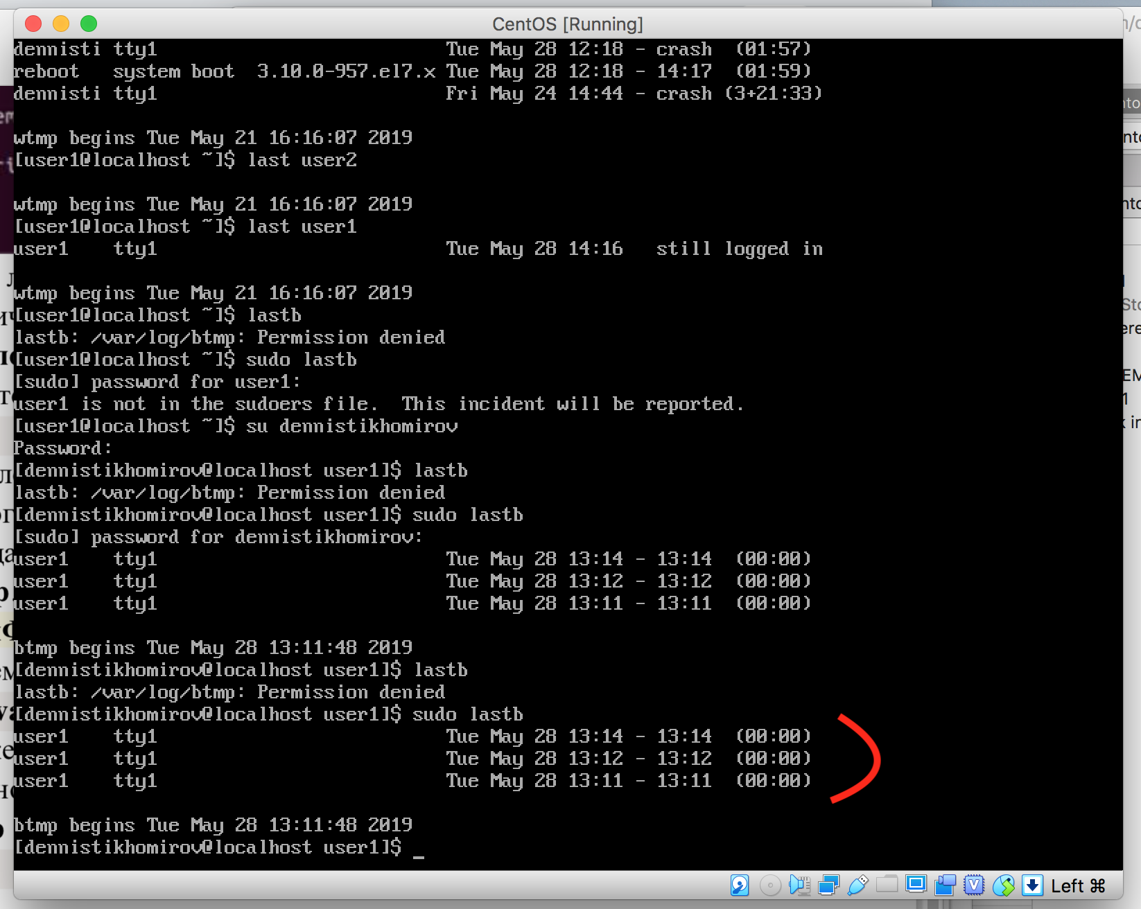

PART 2

1. Get to know the Linux commands. Execute top, free, ps commands with various options.

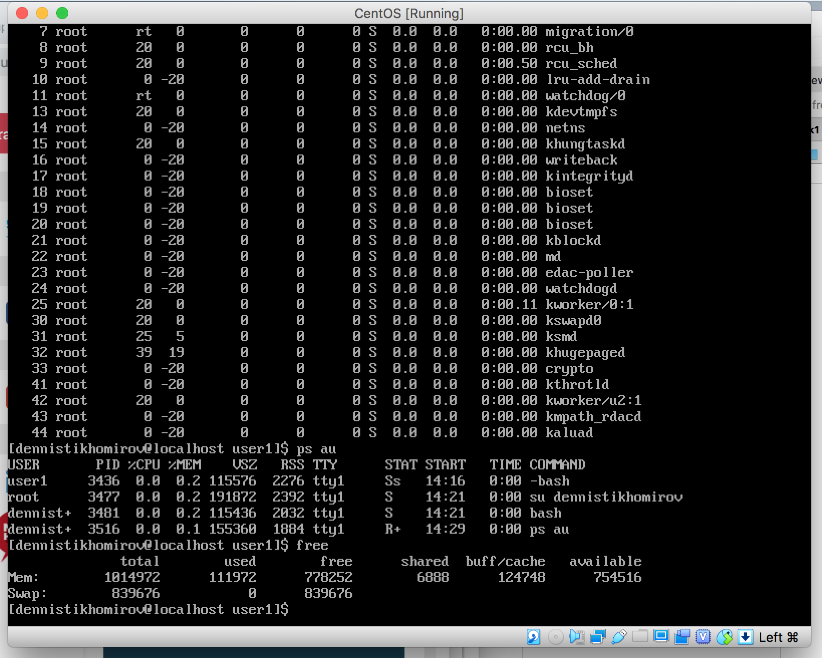

Create a symbolic link s_link to file5 in the lab1 directory

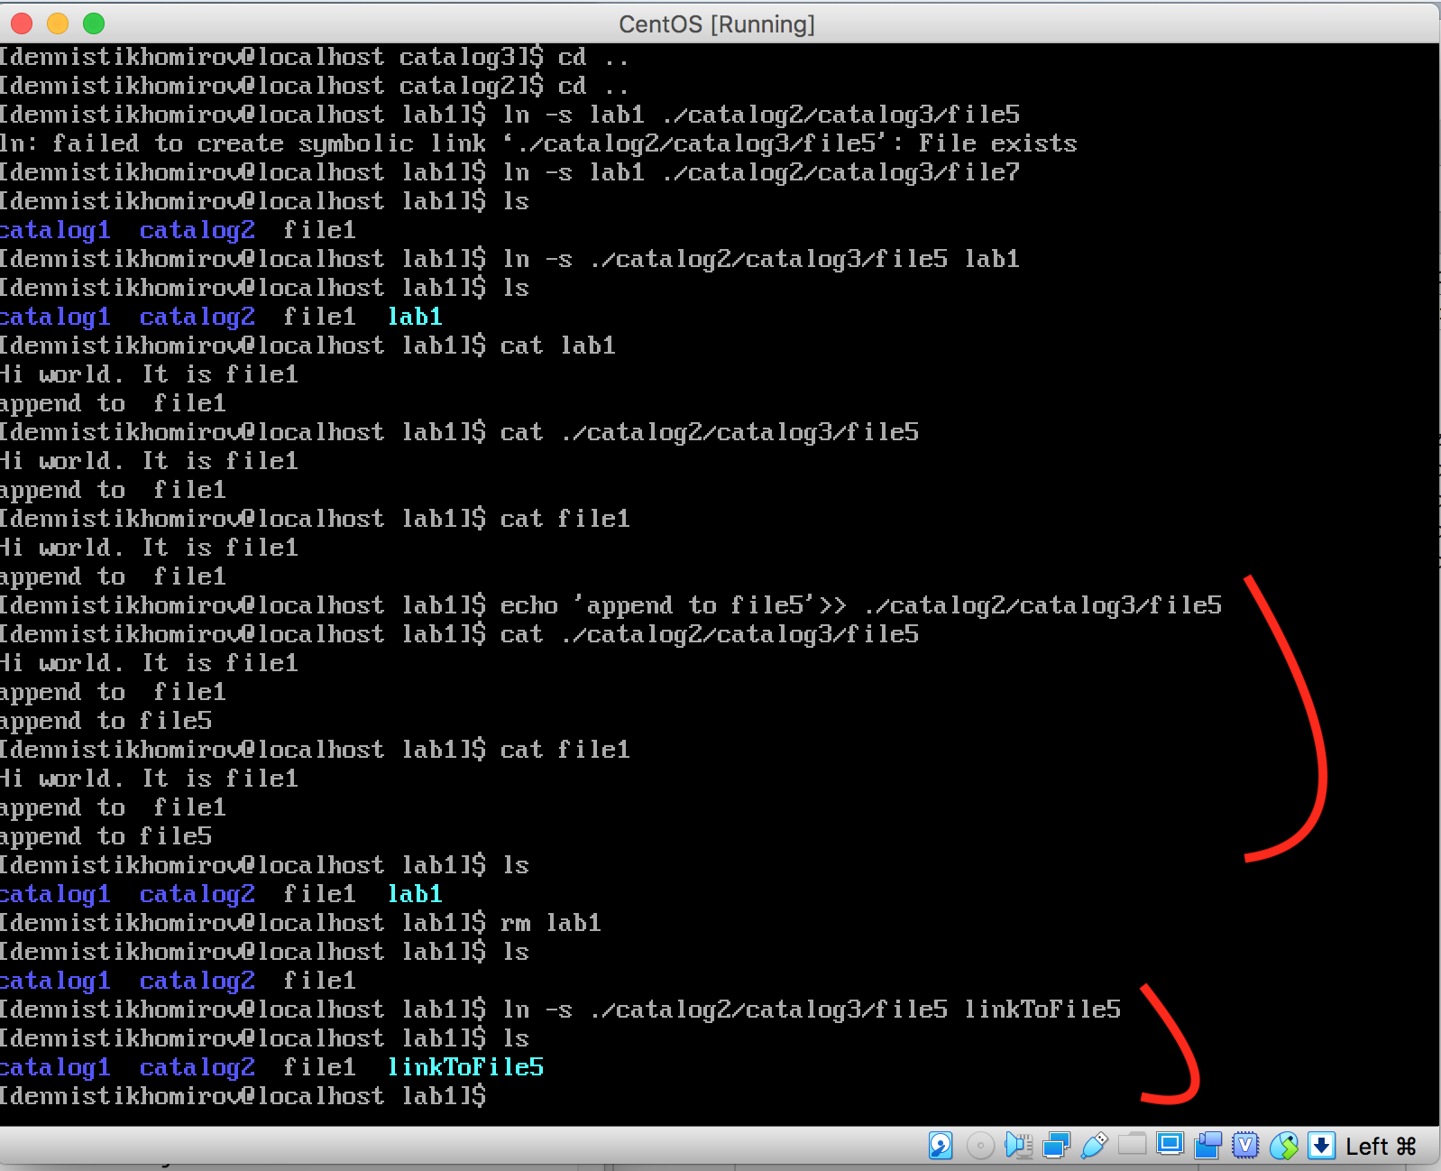

View structure created directories and view the contents of files.

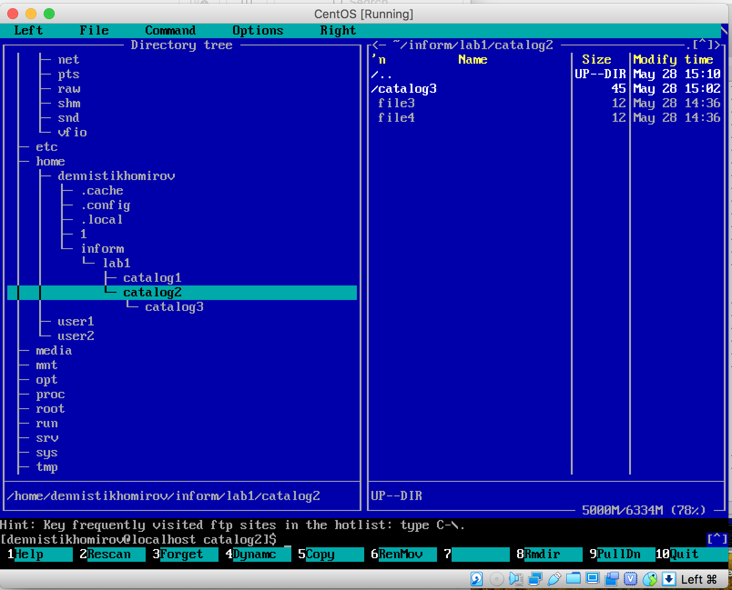

PART 3

Cinderella!

COMING SOON ………

This file contains full description of "Cinderella" task.  
Three different file types was placed in directory ./file_mess  
Directory contains video files .mp4, audio files .mp3 and books .pdf, .chm,

.djvu  
So your tasks are:

1. In directory task1 create 3 directories. video, audio, books.

2. _Move_ audio files to audio directory, video files to video and books files to books.

3. In the video directory create 3 subdirectories 80x, 200x, latest

4. From video driectory _copy_ files that contain date from 1980 to 1989 to directory 80x, from 2000 to 2009 to 200x, from 2014 to 2016 to latest

5. Run the MC program (Midnight Commander): mc. View structure created directories and view the contents of files. (screenshot)

6.After files are moved to correct directories create archive task1.completed.tar.gz with all files. Send archive to lector.

cd ../

tar -cz task1 > task1.completed.tar.gz Hint: use globbing pattern with wildcard